January 2010

eCTD Variations
Q&A document

From 1.1.2010 the Variation Regulation 1234/2008 becomes operational. For the EU-Procedural Guideline click here and for the Submission and Processing of Variation in MRP – click here.
This document uses a question and answer format to address some of the impacts of the new Variation Regulation on the submission of eCTD format dossiers and guidance and best practice for creating submissions in eCTD format.
Further answers to general questions concerning the new Variation Regulation can be found at the CMD-h website (http://www.hma.eu/fileadmin/dateien/Human_Medicines/CMD_h_/procedural_guidance/Variations/CMDh-132-2009-Rev0.pdf)

General Points for All Variations

Q 1.1: Should the submission mode element in the envelope be used for sequences associated with Variations and extensions?

A1.1: Yes, this is specified in the EU Module 1 Specification, and in the general terms in the EU Procedural Guideline.
The submission mode has to be used, and must have an identical value, for all of the sequences in an extension or variation activity.
The submission mode should not be used for sequences that form part of an activity that is not an extension or variation.

Q 1.1.a: What submission type value should be used for groups with a mix of different types of variation?

A1.1.a: For mixed groups, the submission type value should be the “highest” variation or extension type. For example, a group consisting of a Type IA and a Type IB variation should use the submission type value “var-type1b”; a group consisting of a Type II variation and an extension should use the submission type value “extension”.

Q 1.2: Please can you confirm that the high level submission number element is only used for the following instances:
- Groupings under Article 7(2)(a), the so-called “annual report”
- Worksharing procedures

A 1.2: Yes, this is specified in the EU Module 1 specification.
However, for point 1, the expression ‘Type IA variations for multiple marketing authorisations’ is used. An ‘annual report’ does not necessarily cover multiple products.
For purpose of handling grouping and worksharing applications all strengths and pharmaceutical forms of a certain product will be considered to belong to the same marketing authorisation.

Q 1.3: Please can you confirm whether the information in the submission tracking number element should include the values of the individual variation identifiers?

A 1.3: The EU Module 1 specification requires the ‘high-level’ procedural number to be specified (e.g. /WS …) together with the product-specific individual number (a so called virtual number).
However, there is no need to include an identifier for each individual variation which is submitted as part of a group, as the group will be handled as one application (according to the highest variation type in the group).
The product specific variation numbers will:
- For CP, be assigned by the EMEA after the submission has been accepted therefore it cannot be included in the envelope by the MAH with the first sequence. Each subsequent sequence in the variation activity should however include the allocated number.
- For MRP, be allocated by the RMS in advance and should be included in the envelope by the MAH with the first sequence in the variation activity.

Single Variation for a Single MA

Q 2.1: How should a simple variation be presented?

A 2.1: The diagram below shows the envelope element from the eu-regional.xml file for a single variation for a single MA. The use of the submission type, submission mode and submission tracking number has been highlighted. This example is for a Centralised Procedure submission and shows the first sequence in the variation activity.

Submission type = the type of the variation (e.g. “var-type1b”)
Submission mode = “single”
Submission tracking number = For first sequence in the regulatory activity, use just the procedure root number (e.g. “EMEA/H/C/000123”)
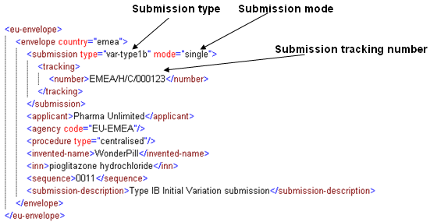

This diagram shows an example of the element values that might be used in a subsequent sequence in the activity.

Submission type = the type of submission (usually “supplemental-info”)
Submission mode = “single”
Submission tracking number = For a subsequent sequence in an activity the full variation number should be used (e.g. “EMEA/H/C/000123/IB/061”
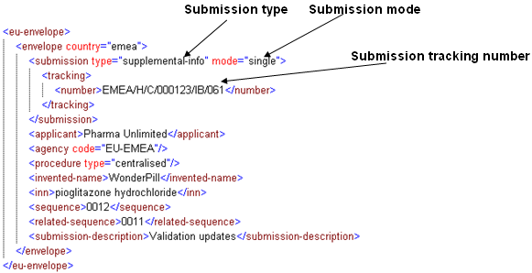

Tracking number for MRP products: see CMD (h) BPG for submission and processing of Variations in MRP, Chapter 1 (eg. DE/H/0450/001/IA/0001)

Q 2.2: Is the eCTD submission mode = “single” applicable to all sequences in that particular variation activity (i.e. not just the initial variation application but also all subsequent sequences concerning that variation including any validation sequences, responses to questions, submission of labelling documents, etc.)?

A 2.2: Yes, this element must be populated for ALL sequences which will be submitted for the variation and extension concerned. (see diagrams in A 2.1)

Grouped Variations for a Single MA

This category includes grouped variations (any) under Article 7(2)(b), or a grouping of Type IA variations under Article 7(2)(a) for only a single MA.

Q 3.1: Is any grouping of Type IA variations for a single MA, that has some delayed notifications in fact a grouping under Article 7 (2)(a) (the so-called “annual report”)?

A 3.1: Yes, this is addressed in the EU Procedural Guideline. This may not necessarily be an ‘annual report’. It could also concern a group of Type IA variations, which include Type IA and Type IA_{IN} but which are submitted immediately after implementation of the Type IA_{IN} concerned.

Q 3.2: Is any grouping of variations for a single MA that happens to contain a Type IA notification that has been delayed a grouping under Article 7(2)(b)?

A 3.2: Yes, this is addressed in the EU Procedural Guideline: if a group of variations contains only Type IA variations, this falls under Article 7(2) (a). If the Type IA variation(s) is/are included with a higher type of variation, then this will be considered as a group under Article 7(2)(b) and will be handled according to the highest variation in the group.
This is applicable to both kind of Type IA variations.

Q 3.3: What can be done if a Type IB or II variation needs to be submitted and affects the same document as a Type IA variation that was planned for submission in an “annual report”?

A 3.3: If the same document affected by the Type IA is also affected by a subsequent Type IB or Type II, the Type IA changes should ideally be grouped with the Type IB/II concerned so that the submitted Type IB/II documentation reflects the actual, latest version (incl the already implemented Type IA changes). This will be in particular applicable when the product information (SmPC and/or PL) is concerned.

2 possible cases:

1. If same document is affected in two different places by two different variations (e.g. first a Type IA affects content on the first page of the document and then a Type II changes content on the third page of the document): not mandatory to submit the Type IA before its 12-month deadline, but it would be strongly recommended to submit the Type IA before or at the time of the Type II to facilitate the MAH’s document management (as a ‘grouped variation’, as appropriate). This would be particularly recommended when the variations affect the product information.

2. If the same document is affected in the same place by two different variations: both changes still need to be notified.

As an example: A Type IA and a subsequent Type II both affect the same document section, the Type IA should not await a notification in the “Annual Report” but should be notified at the same time as the Type II. The applicant should submit only the final version of the document (i.e. the latest version containing the most up to date information from both of the proposed changes); but all the required supportive documentation (e.g. batch analysis data) as required for both the original Type IA and the Type II variations will still need to be included in the variation (submission of ‘grouped’ variations).

It is strongly recommended to submit both variations at the same time (or to submit the Type IA separately just before the Type II).

It is not possible to submit the intermediate document alone (i.e. the document with just the changes from the Type IA) without any other supporting data, cover letter or application form.

Note: In the case that several delayed Type IA variations make changes to a single document in the Annual Report, the applicant should submit only a single version of the document incorporating all of the implemented changes. It is not possible to provide several versions of the same file with the individual changes identified in different versions.

Q 3.4: How should a grouped variation of the same type, for a single MA, be presented?

A 3.4: The diagram shows an example of a Centralised Procedure variation grouping two Type II variations for the same MA.

Submission type = the identical type for all variations (e.g. “var-type2”)
Submission mode = “grouping”
Submissions tracking number = use the next procedure number but suffixed with ‘G’ (e.g. “EMEA/H/C/000123/II/062/G”)

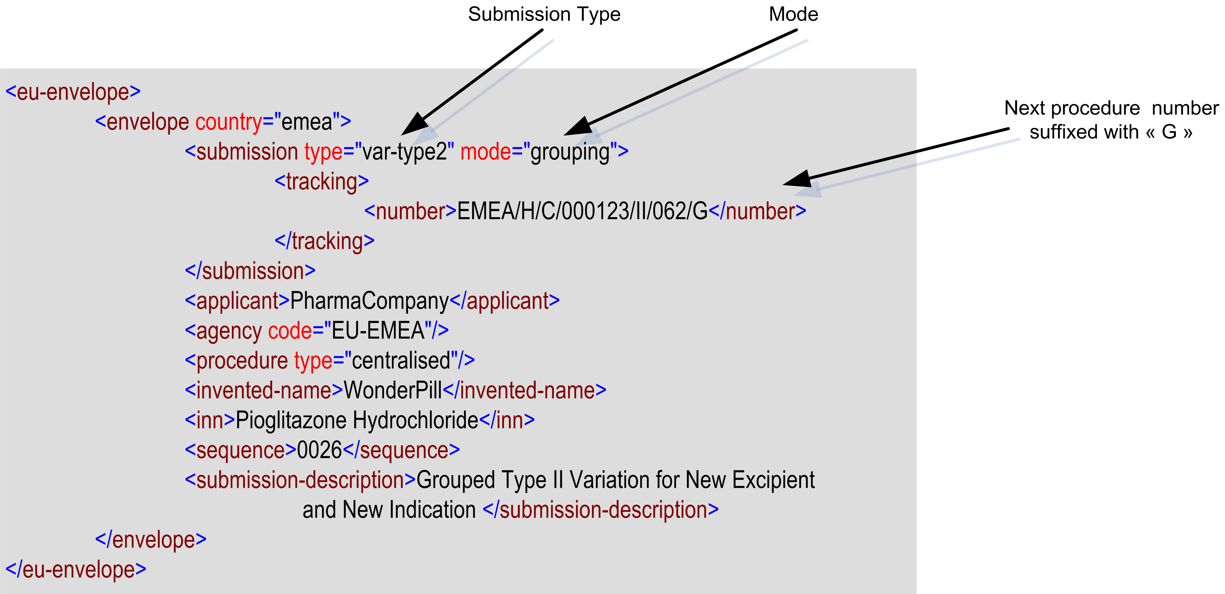

Tracking number for MRP products: see CMD(h) BPG for submission and processing of Variations in MRP, Chapter 1 (e.g. AT/H/0234/II/003/G).

Q 3.5: How should a grouped variation of different types, for a single MA, be presented?

A 3.5: The diagram shows an example for a Centralised Procedure variation for a grouping of a Type IB and a Type II variation for the same MA.

Submission type = the highest submission type within the grouped variations (e.g. if grouped variations are IB and type II, use “var-type2”)
Submission mode = “grouping”
Submission tracking number = use the next procedure number for the highest submission type with the suffix “G” (e.g. “EMEA/H/C/000123/II/063/G”)

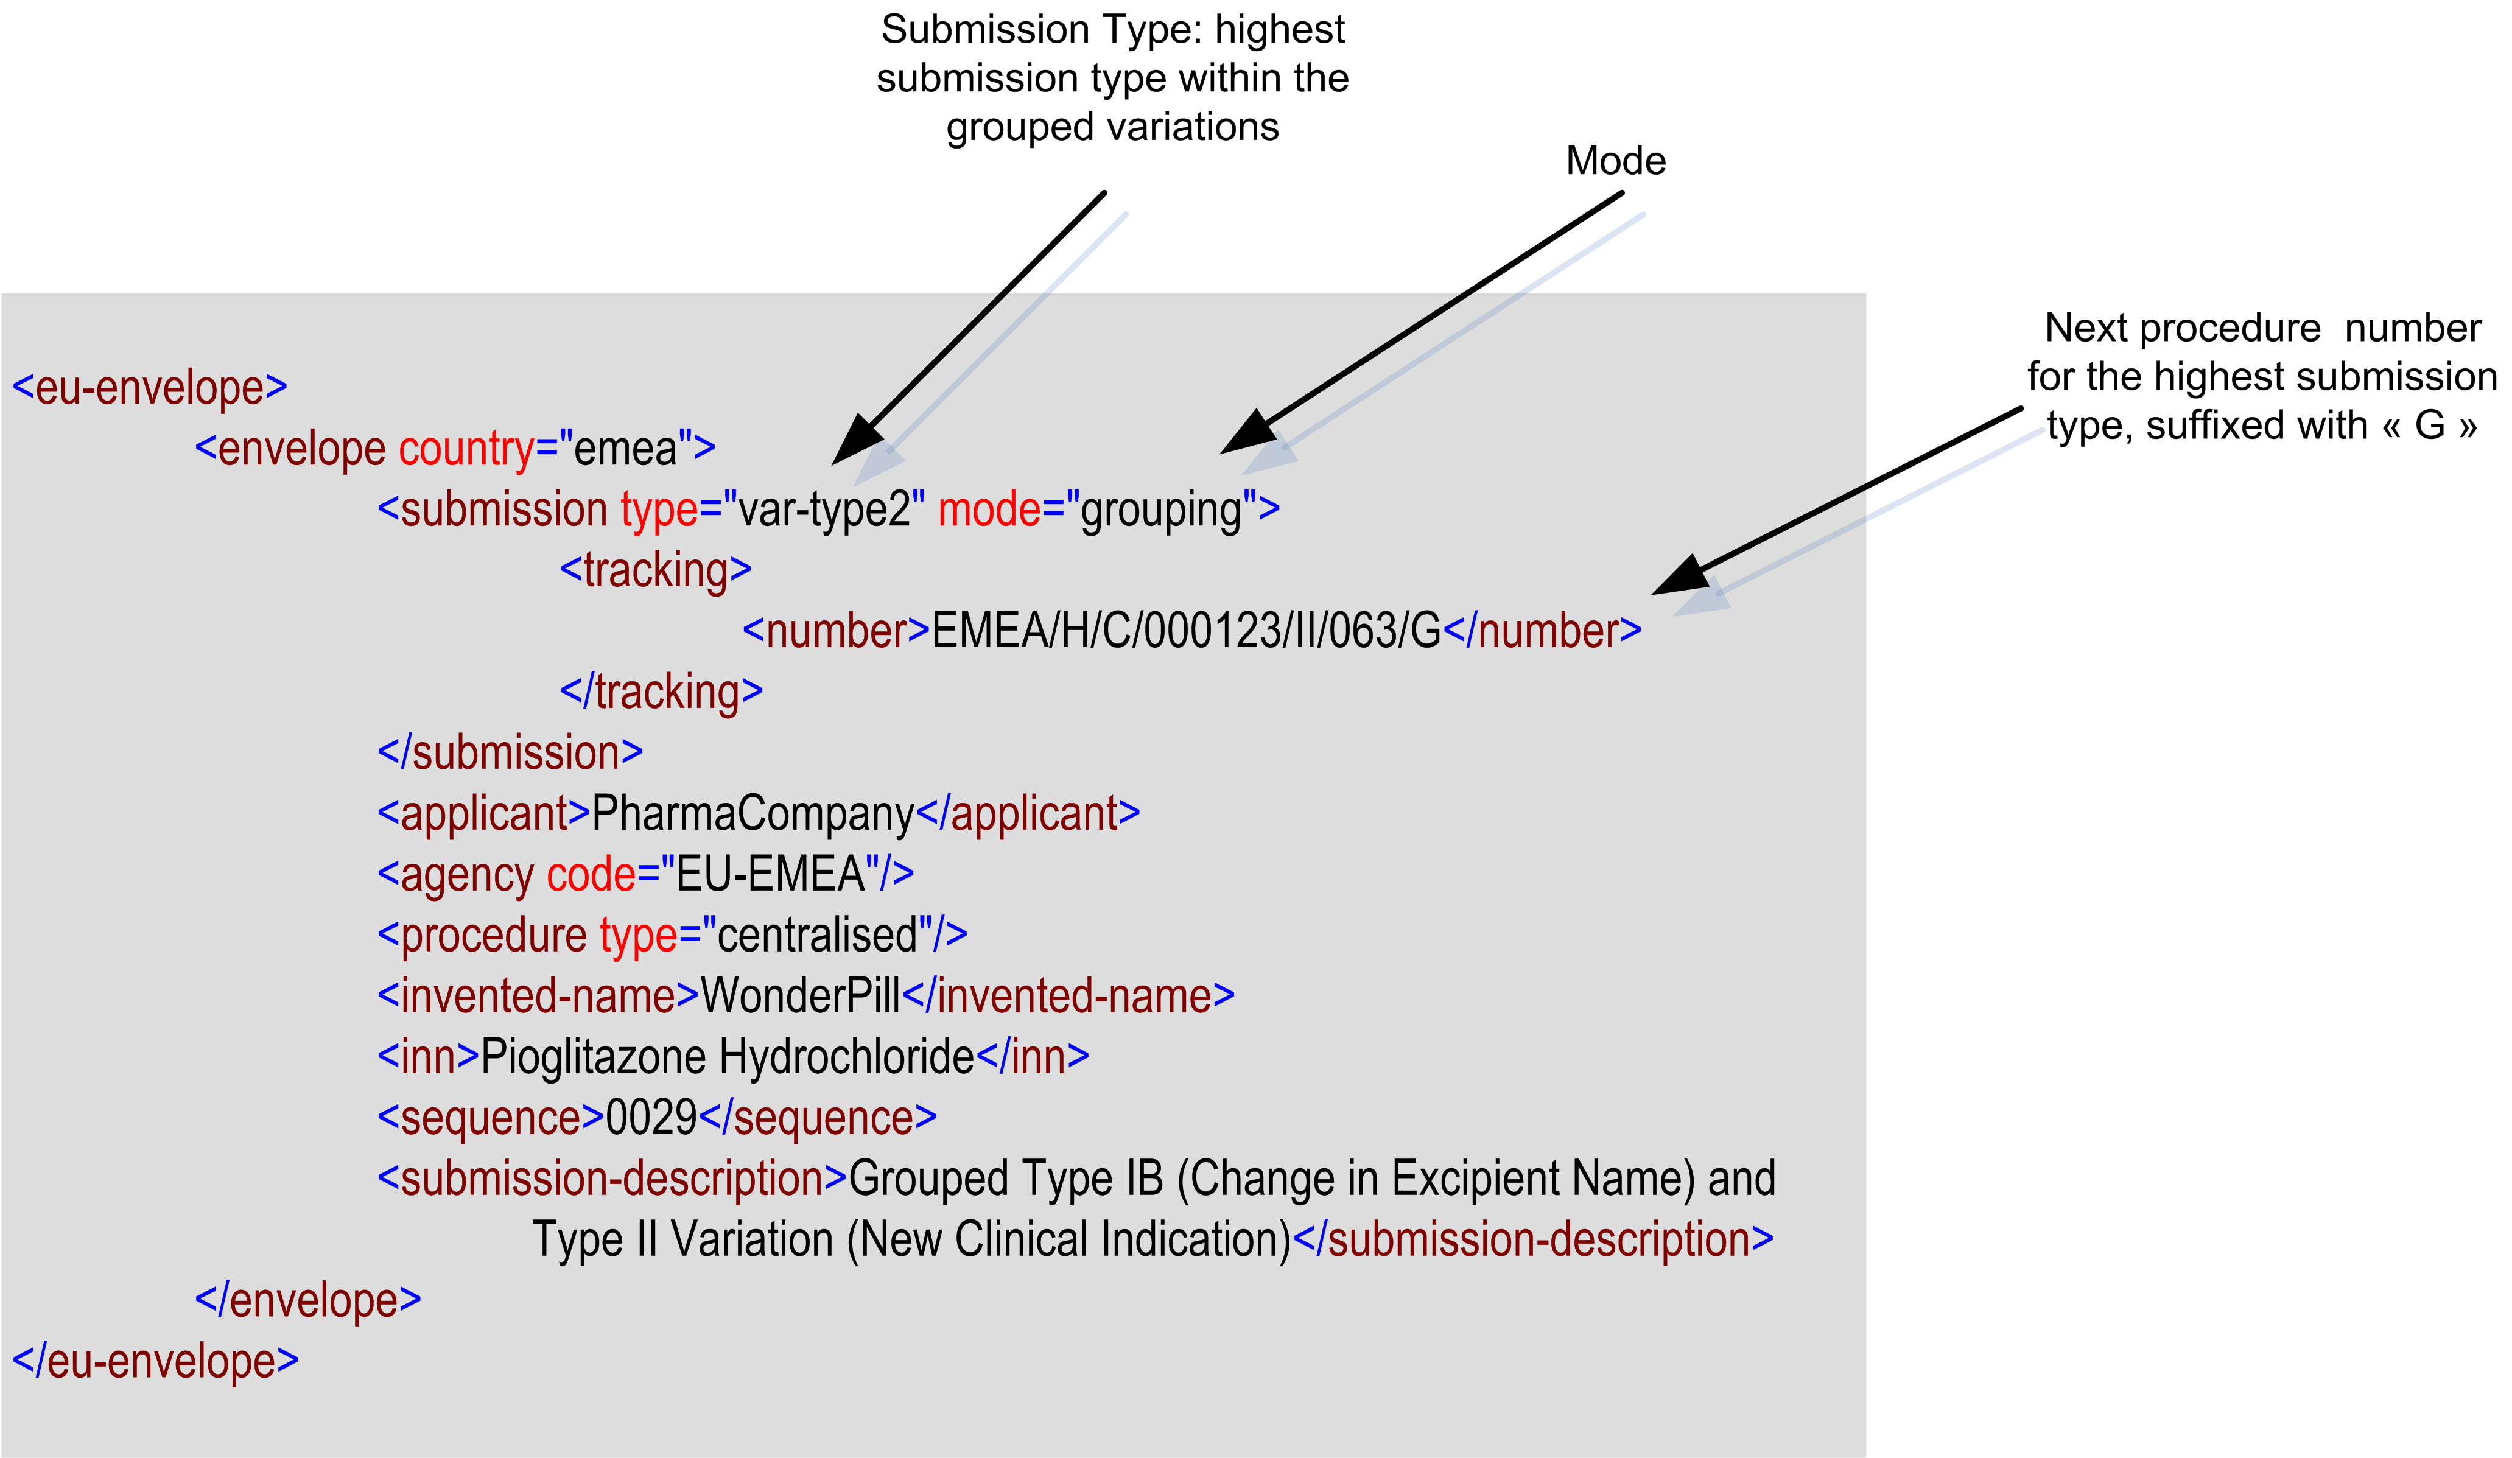

Tracking number for MRP products: see CMD(h) BPG for submission and processing of Variations in MRP, Chapter 1.

Q 3.6: How should a single integrated sequence for a grouped variation be created?

A 3.6: Submissions of grouped variations for a single MA should be submitted as a single eCTD sequence for the product concerned. The cover letter and application form should identify the individual variations included in the grouping. In the Application Form the “present-proposed” section should clearly indicate which dossier section number(s) are in support of which variation.
If two or more variations in the grouping make changes to the same document then only one document, incorporating all of the proposed changes, should be submitted (i.e. if two of the variations make changes to the SmPC, only one SmPC document should be submitted with both sets of changes included). The procedure is prescribed in the EU Procedural Guideline.

Q 3.7: How should the Applicant differentiate the content of the different variations grouped together?

A 3.7: This should be done within the Application Form and Cover Letter, rather than in the files submitted in the submission. The supportive documentation would be integrated.
For worksharing procedures, there is the need to include also which products are relevant to which CMSs. Every included product has to have its own eCTD.

Q 3.8: What should the applicant do if there are multiple changes to the same file being kept for a periodic annual report?

A 3.8: For example, the address of a manufacturer of the finished product, not responsible for batch release (Type IA), has changed in March 2010, and the same address has changed again in September 2010.
Normally all these changes to the same file should be included and summarized in the Periodic Report into a single file.
Alternatively the applicant can submit several sequences to separate the incremental changes to the document, but these would not necessarily be treated as a single grouping and may lead to separate fees for each variation.
See also Q 3.3 above.

Q 3.9: Should the Applicant submit a “Consolidation Sequence” if there are rejected variations?

A 3.9: Rejected variations should not appear in the current view. It is understood that a single decision will be made about a grouping but that this will include separate approval and rejections of each individual variation. In the case of rejected variations, the applicant should submit a “consolidation” sequence to remove from the current view of the eCTD any documents associated with the rejected variation. This should be created in the following manner:

- Any leafs associated only with the rejected variation, and where content was submitted for the first time in this section, should be updated with a “delete” operation leaf
- Any leafs associated only with the rejected variation, and where content was submitted for a second or subsequent time in this section (i.e. the leaf for the variation in question was submitted with a “replace” operation”), should be updated with a “replace” operation leaf that points the content back to the version of the leaf used prior to the submission of the variation that has been rejected.
- Any leafs associated with the rejected variation but with content also shared with other approved variations should be updated with a “replace” operation leaf that points to a new content file that contains only the approved content (i.e. the proposed texts associated with rejected variation have been reverted back to the text that was approved before the start of the grouped variation activity).

When creating the consolidated sequence, it is important to note that the content to be removed from the “current view” may be contained in more than one sequence (e.g. if a Type II variation is rejected, the content may be in the original sequence for the variation application, a sequence for the validation updates, in a sequence for responses to questions, etc.). The applicant should submit only one single consolidation sequence that removes the content associated with the rejection from all of the previously submitted sequences associated with the variation activity.
Within the envelope, the “submission type” should be identified as supplemental-info. The consolidation sequence is part of the variation activity, so it should have a “related-sequence” value that matches the sequence number of the initial sequence for the variation activity. Ideally, the “submission-description” should include some text to identify the sequence as a consolidation sequence after variation rejection.

For complete rejections of a variation: the current view should only show the latest approved document versions and possibly pending documents from ongoing new variations.

Q 3.10: Should the Applicant submit a “Consolidation Sequence” for Withdrawn Variations?

A 3.10: In the case of withdrawn variations (from a group) during the assessment of the variation grouping, the applicant should submit a “consolidation” sequence to remove from the current view of the eCTD any documents associated with the withdrawn variation. This should be created in the following manner:

- Any leafs associated only with the withdrawn variation, and where content was submitted for the first time in this section, should be updated with a “delete” operation leaf
- Any leafs associated only with the withdrawn variation, and where content was submitted for a second or subsequent time in this section (i.e. the leaf for the variation in question was submitted with a “replace” operation”), should be updated with a “replace” operation leaf that points the content back to the version of the leaf used prior to the submission of the variation that has been rejected.
- Any leafs associated with the withdrawn variation but with content also shared with other approved variations should be updated with a “replace” operation leaf that points to a new content file that contains only the approved content (i.e. the proposed texts associated with rejected variation have been reverted back to the text that was approved before the start of the grouped variation activity).

Note that the “submission type” to be identified in the envelope should be supplemental-info. The submission type value of withdrawal should not be used in this circumstance and should be reserved for an activity to withdraw a licence/product. Ideally the “submission-description” should include some text to identify the sequence as a consolidation sequence after withdrawal of a variation.

Q 3.11: What shall I do if during a grouped variations of different types, for a single marketing authorisation, the highest variation(s) that are used to qualify the group submissions are withdrawn?

A 3.11: The Procedure number will not change. There are no other consequences for eCTD than identified above under rejection/withdrawal (see A3.9 and A3.10).

Q 3.12: Withdrawing – Rejecting for all submission modes
What should I do if the complete variation is rejected?
What should I do if the complete variation is withdrawn?

A 3.12: If a complete variation is withdrawn or rejected, the applicant should submit a consolidation sequence to remove the scientific and regulatory content from the current view of the eCTD submission in the lifecycle. The general rules described in A 3.9 and A 3.10 should be followed.

However, not all of the content submitted in the rejected or withdrawn submission should be removed from the current view of the eCTD. It is useful to retain certain administrative information in the current view and some scientific or regulatory information may be used in future submissions (e.g. a clinical study report for a rejected new indication will still contribute data about clinical safety in future submissions). Therefore, the following rules should be applied

In Module 1: The original cover letter and application form should not be removed from the current view. In an MRP or DCP, the tracking table should also not be removed All other documents should be removed following the rules described in Section 3.10. Particular care should be taken to remove from the current view the versions of any labelling documents associated with the rejected or withdrawn variation.

In Module 2: All summary documents should be removed from the current view.

In Module 3: All content files associated with the rejected or withdrawn variation should be removed from the current view so that only the previously approved content remains in the current view.

In Modules 4 and 5: The applicant should not remove from the current view any content unless the reviewing agency specifically states.

- Type IA Grouping and Worksharing Covering Several MAs

This category includes grouped Type IA variations under Article 7(2)(a) for several MAs and Worksharing procedure under Article 20, covering several MAs.

Q 4.1: Can a grouping/workshare cover variations for products registered through different procedures?

A 4.1: Currently pure nationally authorised products cannot be included in workingsharing/Type IA grouping. This should however become possible after Jan 2011.
However, the Regulation foresees that ‘worksharing’ can include products authorised via DCP, MRP and CP from the same MAH.

Q 4.2: Can a Worksharing include a Grouped Variation?

A 4.2: Yes, a worksharing procedure can concern a single variation or a group of variations, as long as the variation(s) are the same for each of the products concerned. This is explained in the Regulation and in EU procedural guideline.
The procedure number for Worksharing has to be used (WS) and all individual procedure numbers to be identified.

Q 4.3: How should a Single Integrated Sequence be created?

A 4.3: When creating the single integrated sequence for a grouped or worksharing variation across several MAs, the applicant should note that the current eCTD specification cannot manage more than one MA (product) in a single eCTD sequence. Therefore, the general process will be to create a separate eCTD sequence for each MA (product). This will allow the content and envelope information associated with each product to be managed, as well as allowing the applicant to preserve the lifecycle leaf information. In general the points in Q 3.6 apply.

In addition, the applicant should pay attention to the following points when creating the individual eCTD sequences for each MA (product):

- Within each MA (product) specific sequence the applicant should edit the envelope values to reflect the product specific values. In particular, attention should be paid to the following envelope metadata values which will almost certainly be different for each product
  - submission tracking number – this should reflect the product specific procedure and tracking numbers
  - INN and invented name – this should reflect the product specific INN and invented names
  - sequence and related-sequence – this should reflect the product specific sequence number and related sequence
Note: The following envelope metadata values should be identical for all products
  - submission number – this is the Grouping or Workshare procedure number and is the key identification number used to associate all of the separately submitted sequences
  - submission type and mode – these must be identical for each MA (product) specific eCTD sequence being made for the grouped/workshare submission
  - agency code – the NCA identified must be identical for all products.
Note: The following envelope metadata values may be the same or different for any/all MAs (products)
  - applicant
  - procedure type
  - submission description

- Content for the submission should be identical in each sequence for each MA (product) for the following sections of the CTD.
  - Cover letter
  - Application form
  - Content associated directly with the proposed change
Where the content is identical the applicant should try to use the same leaf titles in each product specific sequence.
While the content of these sections may be identical, it should be noted that the leaf lifecycle information will almost certainly not be the same from one MA (product) specific sequence to the next in the Grouped or Workshare application. For example, a variation to introduce a new analytical method may be “new” for one product but a “replace” leaf for another product.

- Content for the submission may be different for each sequence for each MA (product) in other parts of the CTD dossier structure, particularly for the product specific supporting documentation for a variation (e.g. the information on specific batches of a product used to show that a new analytical method is valid, or the product specific SmPCs submitted when the MAH address changes).
It should be noted that each MA (product) specific sequence must only contain content for that particular MA, any content specific to another MA should not be included in the sequence. Inclusion of content for another MA may confuse the assessor and may lead to delays while the issues are resolved.

It is expected that for each product, there should be a separate eCTD sequence submitted, each with their own envelope. The submission will contain a common application form and common cover letter.

A new eCTD sequence, containing the relevant documents for each product concerned by the worksharing procedure should be submitted. I.e. submit the individual eCTD for each product as is normally the case, but provide these as part of one application even if each dossier needs to be updated individually (lifecycle maintenance). Worksharing will then subject these eCTD submissions to a common evaluation procedure, but the normal eCTD submission principles continue to apply.

Q 4.4: In cases where several eCTD sequences (with the same content but different envelopes for different products), how should the variation be sent to the Authorities (one CD with all sequences vs. 1 CD per sequence)?

A 4.4: Ideally one CD or one DVD containing all eCTDs for all products concerned in a worksharing procedure or grouped Type IA covering multiple MAs should be submitted, but in separate folders.

Q 4.5: What shall the Applicant do if at the start of a “grouped Type IA” or “workshared” procedure covering more than one MA the number is not assigned yet?

A 4.5: This is specified in the EU Module 1 specification: it should be indicated in the envelope as “to be advised”. This will for instance apply to CP submissions, as the procedure number is only allocated by EMEA at time of receipt of the application.
In case of MRP – the number should always be assigned by the RMS in advance and indicated in the envelope.

Q 4.6: How should the grouping of type IA variation(s) for multiple MAs be presented?

A 4.6: A separate eCTD sequence must be prepared for each product. (see Q 4.4)
The content of the different variations will not be distinguished within the submission, but within the Application Form and Cover Letter.
A separate EU envelope for each product will be included as well.

Envelope for the first product
Submission type = var-type1a
Mode = “grouping”
Submission number = same grouping submission number for all products, including the “xxxx”.
Tracking number = the next procedure number for the product, with an common “grouping code” for all product (e.g. “IG002”)
Invented name and INN: specific to this product
Envelope for the second product
Submission type = var-type1a
Mode = “grouping”
Submission number = same grouping submission number for all products, including the “xxxx”.
Tracking number = the next procedure number for the product, with an common “grouping code” for all product (e.g. “IG002”)
Invented name and INN: specific to this product

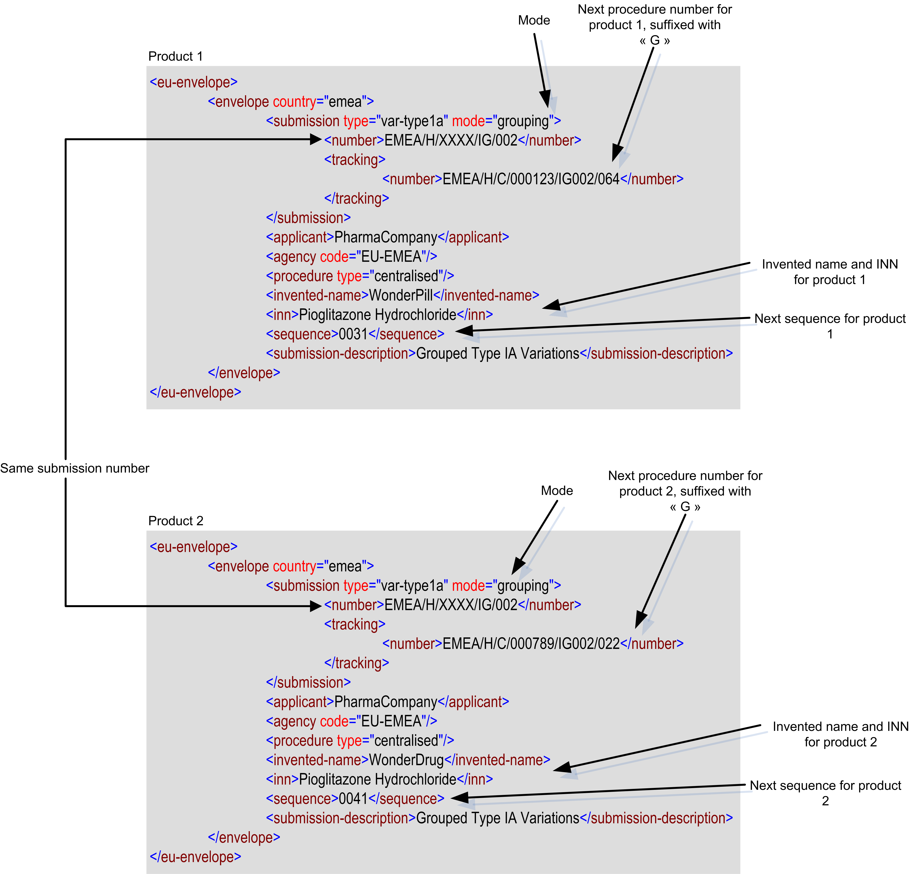

Tracking number for MRP products: see CMD(h) BPG for submission and processing of Variations in MRP, Chapter 1.

Q 4.7: How should a worksharing procedure (type IB and / or Type II variations) for multiple MAs be presented?

A 4.7: A separate eCTD sequence should be submitted for each product with a separate envelope for each product. (see Q 4.4)
For each sequence, there is going to be a common “worksharing number” and a different procedure number but with the same worksharing number included in each of them.

Envelope for the first product
Submission type = var-type2
Mode = worksharing
Submission number = the common worksharing number including the “xxxx”.
Tracking number = the next procedure number for this product, with the worksharing number included
Invented name and INN: specific to this product

Envelope for the second product
Submission type = var-type2
Mode = worksharing
Submission number = the common worksharing number including the “xxxx”.
Tracking number = the next procedure number for this product, with the worksharing number included
Invented name and INN: specific to this product
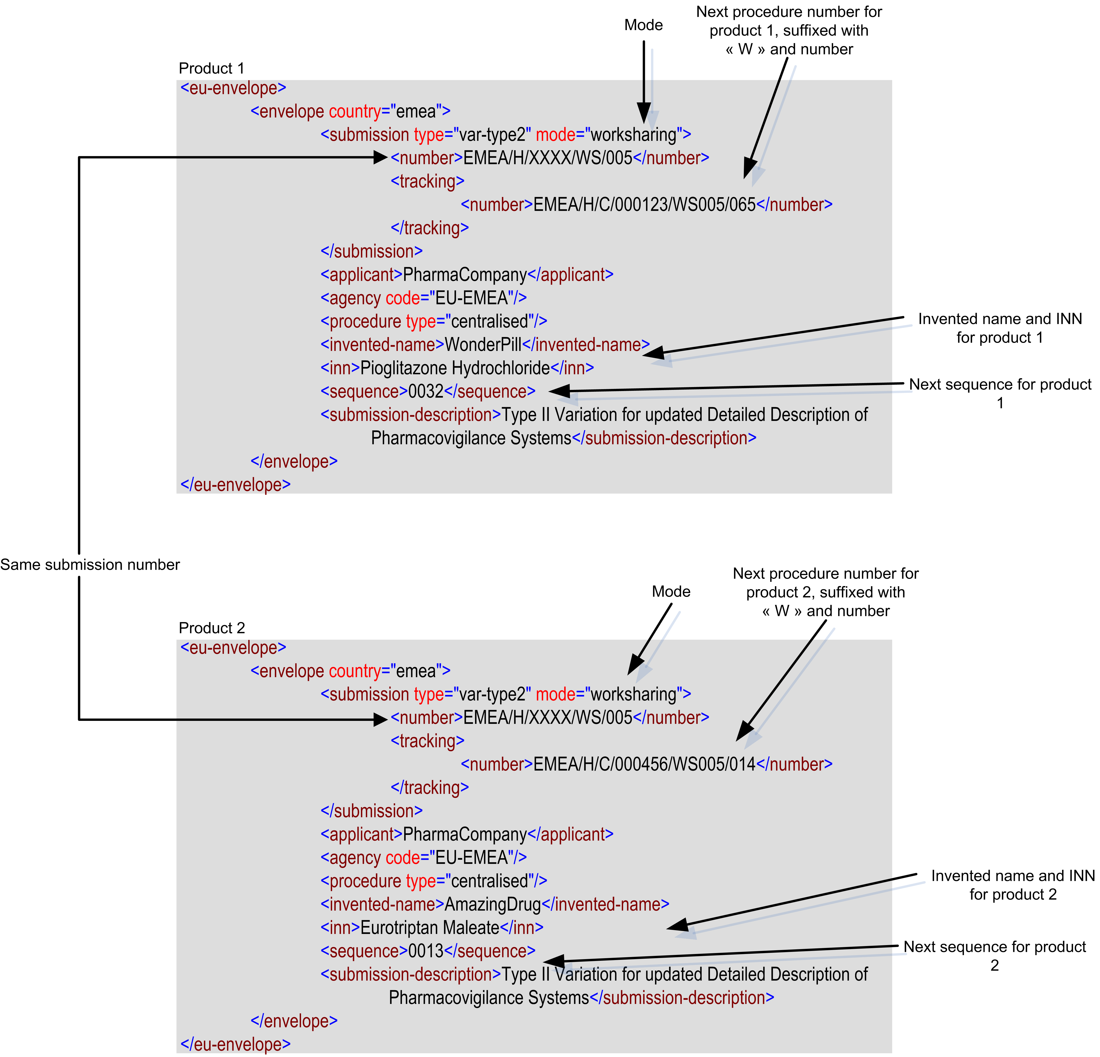

Tracking number for MRP products: see CMD(h) BPG for submission and processing of Variations in MRP, Chapter 1.

Q 4.8: What can we do in case of Withdrawing – Rejecting:
What should I do if the complete worksharing is withdrawn?
What should I do if a product is withdrawn from the worksharing?
What should I do if a variation for a product is withdrawn from the worksharing?
What should I do if the complete worksharing is rejected?
What should I do if a product is withdrawn from the rejected?
What should I do if a variation for a product is rejected?

A 4.8: Rejected or withdrawn variations should not appear in the current view of the eCTD. In the case of rejected variations, the applicant should submit a “consolidation” sequence to remove from the current view of the eCTD any documents associated with the rejected or withdrawn variations.
For further guidance see A 3.9, A 3.10, A 3.11 and A 3.12.

5. WORKSHARING APPLICATION ISSUES

Q 5.1: How should a MAH submit a worksharing application for multiple products for which the dossiers are in different format (e.g. eCTD, NEES, Paper). How can the aplicant ensure that the worksharing application is presented and received as a ‘complete’ application?
A 5.1: The data should be received for each product individually, i.e. as eCTD, NeeS or paper, as applicable. This will allow the lifecycle for eCTD submissions to be maintained and other formats to be used if the NCA requires other formats. However, there would be only one evaluation procedure. The cover letter should very clearly state what is being submitted and in which format.
Variations can be submitted in eCTD format, even if the previous dossier was in paper or NeeS. However, from then onwards the lifecycle continues in eCTD. The fact that one of the products is in eCTD does not make it mandatory to submit the variation for the other non-eCTD products also in eCTD. Each product can continue its previous format. National/EMEA submission requirements should continue to be respected. NeeS and eCTD submissions should preferably be presented on the same hard medium (CD/DVD).

Q 5.2: Worksharing - How should a MAH submit a worksharing application for multiple products which may have different CMSs? Is there any difference if a particular MS or the EMA acts as reference authority?
A 5.2: The reference authority, whether it is a RMS or handled through EMA, will need to receive all applications, even if some products are not authorised in that country, as the reference authority needs to have all of the variations to do the full assessment.
Each CMS should in principle only receive the applications for the products which are relevant to them (e.g. where the NCA is CMS and only one of the variations in the worksharing procedure is marketed in that country, they only need to receive the information for that specific product). However, for electronic submissions, the same CD/DVD containing all products can be submitted to all CMSs/MSs and the eCTD envelope metadata used to identify the products relevant in each CMS/MS.
Where the Agency acts as reference authority the same application will be submitted to all National Competent Authorities involved (RMS(s) and CMS(s)), even if some products are not relevant to some MS(s).
Q 5.3: Worksharing with nationally and centrally authorised products (NAPs & CAPs): When and to whom at the Member States should the MAH submit a worksharing application, when the same application is also to be submitted to the CHMP members?
A 5.3: Involving nationally authorised products (NAPs) in a worksharing procedure currently means that these products have been authorised via DCP or MRP. Products authorised via a purely national procedure currently cannot be included in worksharing at this time.
The worksharing application should be submitted simultaneously to the EMA, Rapporteurs and to NCAs (addressed to both CHMP Member(s) and NCAs). If the CHMP Member(s) address is different from the address of the respective NCA, the worksharing application should be submitted after validation to those CHMP Member(s).
The dossier delivery address for CHMP Members can be found under http://www.emea.europa.eu/htms/human/presub/dossierrequirements.pdf

Concerning the address of NCAs reference is given to Chapter 7 in NTA, Vol 2A or to the websites of the NCAs.
Where the Agency acts as reference authority the dossier requirements for post-authorisation submissions in the centralised procedure should be followed http://www.emea.europa.eu/pdfs/human/regaffair/30033908en.pdf

Q 5.4: How should the aplicant handle ‘interim’ submissions e.g. during validation, SmPC versions, draft responses etc? When should these eCTDs be submitted (milestones)?
A 5.4: The “interim” submissions during regulatory validation can be handled outside the eCTD during the validation period. At the end of the validation period all submitted documents should be resubmitted to the RMS and all CMS with the relevant operation attribute in one eCTD sequence. It should be clearly stated in the cover letter that all documentation has been previously provided outside the eCTD during the validation period. Issues arising during the technical validation of a submission have to be solved before the application can be validated by regulators.
During the Assessment Steps, any additional sequences, e.g. Responses to Questions, should be submitted to the RMS and CMSs. If, due to the tight time lines, the responses are sent outside the eCTD, a new sequence should always follow with any new or updated documents placed in the dossier with the correct operation attribute. This also applies to the final agreed English product information (Summary of Product Chraracteristics, Package Leaflet and Labelling) that should also be submitted to the RMS and CMSs.
Draft responses sent to the RMS during the “Clock-off-Period” should be handled outside the eCTD as they are not considered to be official submissions. Also procedural email correspondence should be exchanged outside the eCTD if not directly relating to the content of the dossier. Any other exemptions should be discussed with the RMS before submission.
Further guidance is given in the CMD(h) Best Practice on the use of the eCTD in MRP/DCP.

6. PARALLEL VARIATIONS

Q 6.1: How to manage Parallel Variations?
A 6.1: The applicant should submit a sequence in which the individual document(s) with consolidated changes from two or more parallel variations have been collected. These documents should be submitted with a “replace” operation to modify the previously approved document.
In case a Type IA variation is part of a group containing Type II, also the principle of a Type IA notification applies. The Type IA change is implemented before submission of the grouping. Only in case a Type IA change is dependent on the outcome of other changes in a grouped application this change may be implemented as soon as the complete grouped application is approved.

7. e-VARIATION APPLICATION FORM

Currently no Q&As.
e AF will be finalised March 2010.

8. OTHER ISSUES

Q 8.1: Where to put the details about an Article 5 procedure in the dossier?
A 8.1: The Art 5 application itself should not be included in the eCTD lifecycle as it is a preparatory submission, in advance of the real variation submission eCTD. It is comparable to a scientific advice or presubmission meeting. Where relevant, a reference to the Article 5 recommendation as published on the EMA or CMD website should be given in the Variation Application Form.

Q 8.2: Are there any new eCTD validation rules to add to the EU Validation criteria with the introduction of v1.4?
A 8.2: The use of the submission-mode attribute can be linked to specific submission-type attributes used in the initial sequence of an activity. That is any activity that starts with a submission type of national variation, variation Type IA, variation Type IB, variation Type II or extension must have a submission-mode attribute in that sequence and in every related sequence.
This business rule has not yet been adopted as an EU eCTD Validation criterion. A Change Request will be submitted and this rule is likely to be included in the near future.

Q 8.3: How to handle an upgrade of a Type IB to a Type II at validation.
A 8.3: The Type IB application will not be invalided as such, but will be upgraded to a Type II.
A new eCTD sequence including a new application form will have to be submitted.

